CMSC 101 / IS 101Y – Fall 2013
Journal Entry 3: Teamwork Reflection
Due Friday, October 11, 2013

Step 1: As soon as your design teams are formed, your team members should share their top 5 strengths with each other.
Share them in order. For example: 1. Connectedness 2. Discipline 3. Positivity 4. Strategic and
5. Maximizer. Be sure that all team members have everyone’s list of strengths. Note: to complete the next step, you need to know the order of the strengths, not just the strengths. Read the brief descriptions of each strength.
Step 2: Sign into your SQ website and use the team talent map to chart your team’s strengths.

Click on the link to the Team Talent Map.

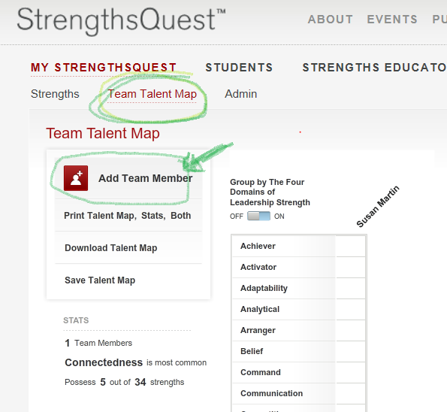

Add each team member by clicking on “Add Team Member”. Type in the team member’s name and then drag each of that person’s top 5 strengths over. Click on “add to talent grid”. Repeat for each person. When you have added all of your other team members, click on “Done”.
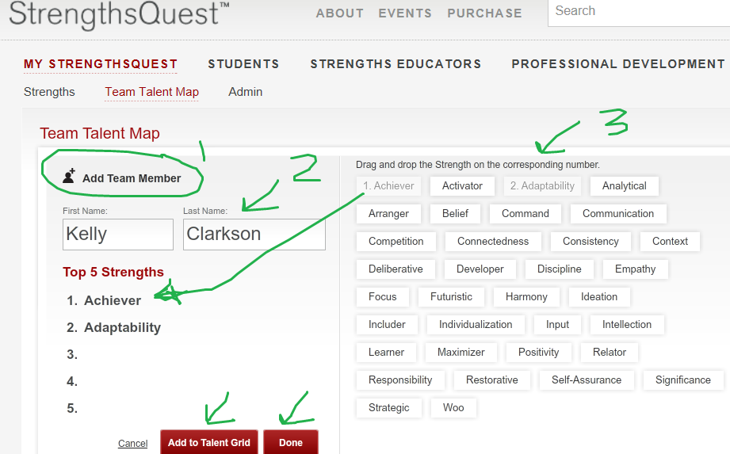

Step 3: Save and print your Team Talent Map. 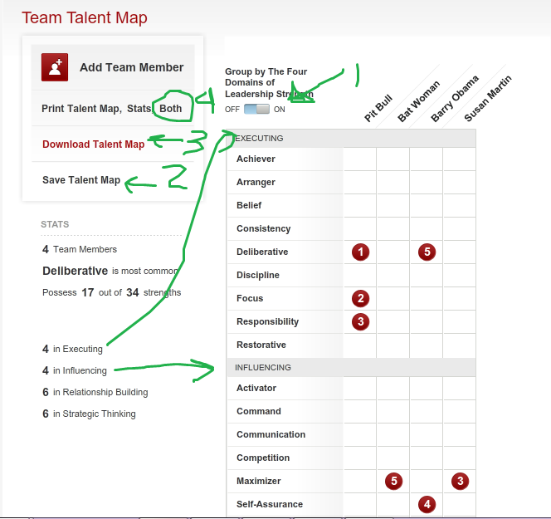
Before you save, download and print be sure that you do the following:
(See numbers on picture above)

- Click on the buttons to group by the four domains.
- Click on Save the Team Talent Map. This will save the map in your SQ account.
- Download and save the Team Talent Map to your own computer.
- Print the talent map and keep it in your course notebook for future reference.

Step 4: As a group, schedule time to discuss your team’s talent map using the following guiding questions.

- What do you notice about the patterns of strengths on your design team?
- What is the most common strength?
- Do you have team members with strengths in all four major leadership areas (Executing, Influencing, Relationship Building, and Strategic Thinking)? Or are you heavy in one or more areas, but missing others?
- How have you seen individuals exercise their strengths already in your team interactions? Discuss a few examples.
- Has anyone not been using their strengths? If so, why has this occurred?
- Do you think your team has operated in a way that reflects the dominant strengths? Why or why not?
- Has your team been experiencing any challenges so far? How might these be explained by the Team’s talent map?
- What steps can you take to become a better functioning team? (For ideas about how to build team relationships, look at your Strengths Insight and Action-Planning Guide that you printed as part of JE#1.)

Step 5: Upload the pdf of your Team Talent Map into Bb JE#3 and respond in writing to the following questions.

Unlike JE#1 and JE#2, you will NOT respond to this JE on the discussion board. The link where you will respond is in the Bb folder for Friday 10/11. Your response will be private, visible only to the peer mentors and instructors.

- Describe how your top strengths can contribute to the success of any teams you are part of in school and/or in the workplace.
- Describe a specific example of a time that you utilized your strengths in the team assignments and other group activities in this class or other classes this semester.
- Consider the tasks that will go into each phase of the team design project. Based on your strengths, what specific tasks do you think you could excel at completing as part of the design team this semester? Be as specific as possible.

