**CMSC 101 / IS 101Y – Fall 2013  
Journal Entry 1: StrengthsQuest  
*Due Friday, September 6, 2013***

**Step 1: Set up your StrengthsQuest account using the following instructions:**

**New Access Code Registration Instructions**

1. Navigate to <http://www.strengthsquest.com>.
2. On the upper-right hand corner of the main page, click **Register.**
3. On the Registration tab, type your access code and the verification code (that appears on the page) in the corresponding fields. Then click **Continue with Registration**.  NOTE: The verification code is not case-sensitive. (If you need help signing in, call the StrengthsQuest Help Desk at 1-888-211-4049 or e-mail [**strengthsquesthelp@gallup.com**](mailto:strengthsquesthelp@gallup.com).)
4. Provide the following information on the Account Information page: • First and last name • E-mail address • A username • A password • An answer to a security question (e.g., What is your mother’s maiden name?). Please also answer any additional questions that appear on the page.

**NOTE:** Your username must be between 8 and 50 characters in length and contain no spaces.

**NOTE:** Your password must be between 8 and 50 characters in length and meet two of the following criteria: contains uppercase letters, contains lowercase letters, contains numbers, or contains any of the following symbols: #, $, !, &.  After providing your information, click **Continue** at the bottom of the page.

**NOTE:** Please double-check the spelling of your email address as this will be the email at which you are contacted if you need to retrieve your password through the **Account Assistance** tab.

**Step 2: Take the StrengthsFinder survey online. You must complete it in one sitting and it takes about 45 minutes.**

Allow 45 minutes. You have 20 seconds to respond to each item. If you lose your connection, click **SIGN IN** and enter your username and password; you will automatically be returned to where you left off. Once you’ve completed the Clifton StrengthsFinder, you will have access to your reports and additional resources in your account. Please click the **MY StrengthsQuest** tab to come back to the landing page where you can see and share your Signature Theme report, journal about success, and read the online StrengthsQuest book.

**Step 3: After you take the survey, print and read two theme reports.**

You get to them by clicking on the MY StrengthsQuest tab.

1. ***Be sure to PRINT the short Signature Theme Report and put it in your course notebook.*** You will need it in class on Friday, 9/6.
2. Also print the ***Strengths Insight and Action-Planning Guide***. (Leave all of the boxes checked and print the whole thing. It will be approximately 10 pages long.) Put ***this report in your course notebook too.*** We will be using it through out the semester

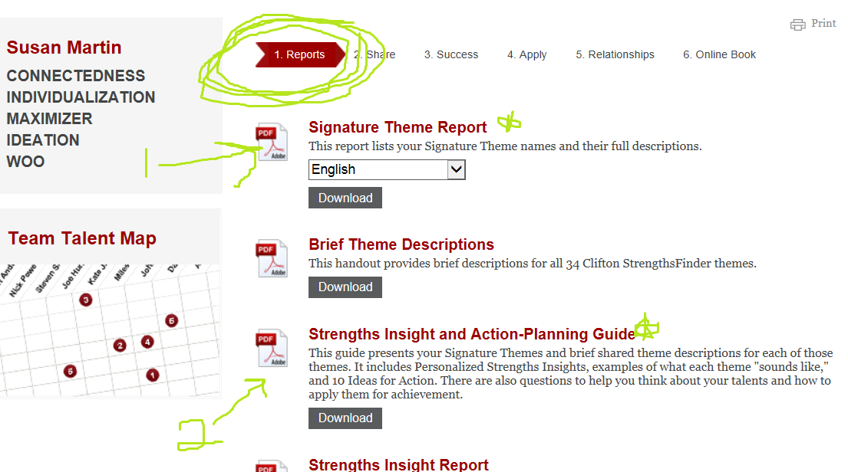

**Step 4: Go to the course Bb site discussion board, introduce yourself and your strengths.**

You will see a discussion thread called “Introductions.” The peer mentors and teaching fellows have already entered their responses as examples. Enter responses to the following questions:

1. Introduce yourself: First and last name (and a nickname you preferred to be called if you have one), Major, Where you are from and what high school you attended.
2. List your five StrengthsQuest themes.
3. Go back and re-read your Signature Theme Report. Describe your reaction to these top five strengths and the possibility that these are your natural gifts?
4. Pick one of the five strengths from the report that you think sounds like you. Describe a situation from any area of your life that you think is a good example of a time when that strength came shining through.